Welcome to the December 2016 edition of Moonterra Archery Club Chat, and a very Merry Christmas and happy New Year to everyone.

Although only a short time has passed since the last newsletter, there has been plenty of action on the range, with a point score round, a working bee, the Club Christmass Party and Ralph’s support for the conduct of the ABA Bowhunter Proficiency Certificate course run at Moonterra!

The FaceBook (FB) page seems to be a hit in keeping members informed, items for sale and is a good medium for everyone to communicate. The web page is also coming along with regular up-dates for those not on FB, and the plan is to have a ‘Members Only’ page – but it is a work in process for 2017.

UPCOMING CLUB EVENTS
The new Club Calendar for 2017 has been released by the committee, and has been sent via email from Bronwyn to all club members, and has also been posted on the web page under the ‘Club Calendar’ tab.
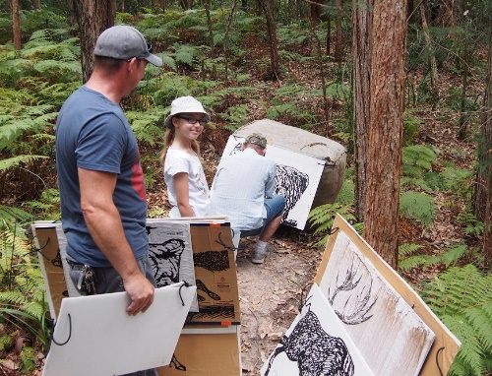
There are always unscheduled events occuring, and members are encouraged to use the range, but please take out your rubbish and don’t forget to lock the gate if you are the last one out. Unfortunatly we had a break-in (connex) and we would ask you to be vigilant if your on the range and report any suspicious activity to the committee.
Thanks to Attila we now have decent targets on the Yellow, Black and Green ranges. They are the brown tar papered ABA targets placed on backing boards and are a huge hit with range users. They are well placed, challenging and a little tip – you will need your binoculars to see the scoring rings!

CLUB PRESIDENT COMMENTS
I would like to take this opportunity to thank all those members who supported the work that has been conducted around the club this year, brilliant. A special thanks to Ralph from FULLDRAW ARCHERY for donating the 3D target for the raffle at the Christmas Party which was a huge hit this year, but more on that later in the newsletter.
We have had a lot of new member enquiries and new members join Moonterra – a very warm welcome to you all and I hope to catch you at the range in 2017.
I hope everyone has a safe and happy Christmas and New Year – looking forward to seeing you all in 2017.
Pete

NOV CLUB POINT SCORE
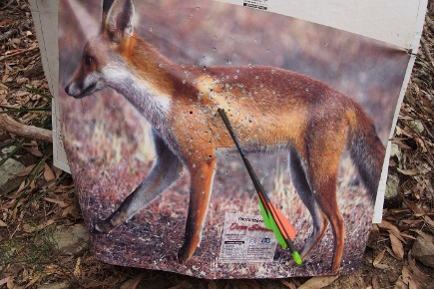
The November club point score had another good roll out with the scoring round conducted on the Green Route. The Green route is a challenging course, but there were some great shots and scores during the course of the day. If I didn’t mention Shanes best shot of the day, I wouldn’t hear the end of it – got to admit – great placement!
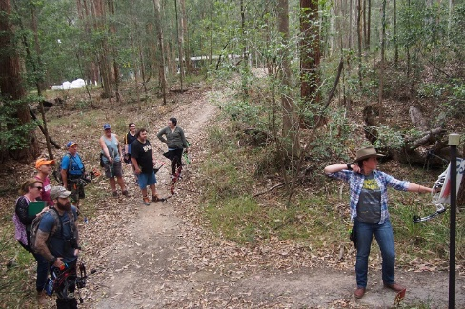
If you haven’t been on the Green Route, it is a little up hill, down dale and travels through and over re-entrants and is a great range, and as highlighted – has the new targets, so next time your out at Moonterra test yourself for the next club shoot.
We had 5 groups attend of between 3-4 per group, and a special thanks to Lez, Bill, Atilla and JB for setting the range for us all prior to main stream arrival.
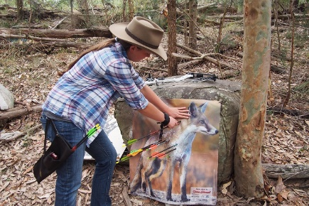
It is great to see some of the newer members trying their hand at the club point score events as it is a great way to meet other archers, to learn and progress your archery skills and above all else – have fun in the sport, be outdoors, in the fresh air and sharing the experience.
As always there is a lot of banter at the club point score days and a lot of rivalry between classes – ‘Bow Hunter visa Free Style’ as an example, and I first learnt this banter when visiting the Norfolk Island Comp – ‘Trads’ (long bow/ re-curve) and ‘Wheelies’ (compound bow). Not quite the same as Norfolk, but a healty rivalry none the less – just means more prizes at the next General meeting. You have to be in it to win it (-:
ABA BOWHUNTER PROFICIENCY CERTIFICATE (BPC)
Thanks to Ralph from FULLDRAW ARCHERY, he ran a BPC course for us at Moonterra over the weekend 10/11 Dec 16, with 13 members attending. What is a BPC course? I hear you ask – well as Australian Bowhunter Association (ABA) members you receive your magazine subscription – ‘Archery Action’ and you will notice pages with ‘Game Claimed’ in the magazine. In order to claim game and be covered under the ABA you need to have completed a Bowhunter Proficiency Certificate (BPC) course and registered with the ABA. It is not an annual requirement, you simply have to have complete the course conducted by a certified organisation – which Ralph is certified to conduct courses.
The course has a theory and practical phase. We had an opportunity to follow the National Bowhunter Education Manual chapters collectively and also to hear from Ralphs experiences as a bowhunter prior to completing the theory exam. This is followed by a pratical archery test, which also highlighted the need for shot placement to take down game cleanly and efficiently.
Overall a great course, and even if you do not claim game for recognition in the ABA/ Archery Action – it was a great opportunity to further develop our archery skills, to meet and greet other archers with similar interest and to share ideas and details from others that are more experienced. Highly recommended.
____________________________________
MONTHLY STORY
MOONTERRA Christmas Party – 2016
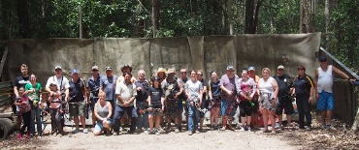
Every year, Moonterra conducts a Christmas Party at the range; not your conventional party, but more of an end of year gathering to shoot at 3D targets placed out on the range and to bring a plate of food to share at lunch time. This year we had a great turn out, despite the date change with families, friends, archers and non-archers turning up to share the experience. And an experience it is, particularly at the end, shooting the ‘Steel Pig’, but more on that later.
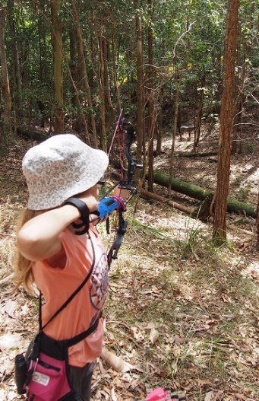
Thanks to Ralph for providing the 3D targets and to Attila, Kerry, JB and Bill for setting a challenging 3D range. I would point out that they set the range from specific firing points, but if you haven’t shot this practice before at Christmas it has many different firing points along a single track from anything up to 60m down to 10m, from kneeling to standing to get the best shot and to cater for all levels and age groups.
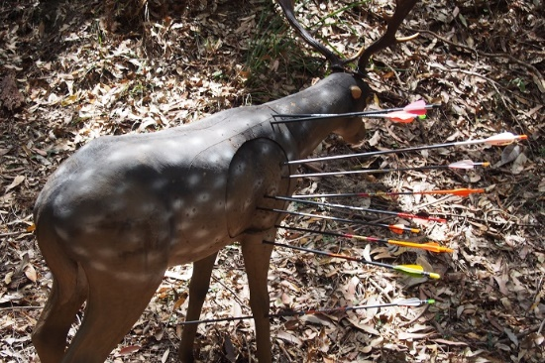
The targets are placed on both sides of the track which rises on one side and drops away on the other, and dependant on your firing point can also be quite flat. It is always a great shoot, and the targets this year were well placed and gave everyone the opportunity to shoot at 3D targets rather than ABA paper targets. If you have not shot at 3D targets before they are very challenging because there is no bail to stop your arrow if you miss or are slightly off the mark! A deer target at 40m, as an example, is challenging because an incorrect judging of distance can mean your arrow flies under or over the target – despite its size, and if you miss at the Christmas 3D shoot, the rivalry is ever present.
Everyone brings a plate of something to supplement the club lunch, and a very big thank you to everyone that came to the event and brought food. There was Christmas ham, prawns, and various forms of cooked chicken, complemented with some great homemade salads. Everyone ate well, a feast fit for a King!
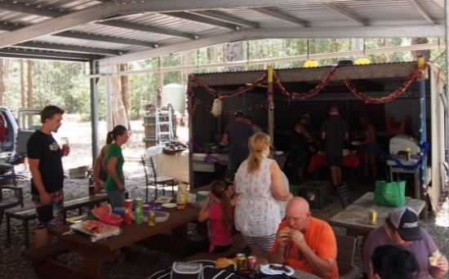
During the break the raffle was conducted and the first prize donated by the club was a holiday for 2 and second prize was a 3D target donated by Ralph from FULLDRAW ARCHERY. They were great prizes and congratulations to the winners of the 2016 Christmas raffle. That was the main raffle event, but there were more opportunities to win prizes at the ‘Steel Pig’ shoot which is a traditional event at Moonterra for those willing to forego and arrow or two at this particular target. I personally saved 4 arrows for this event through the year and won a box of chockies! Not sure of the comparison with 2 lost arrows out of the 4, but a heap of fun.
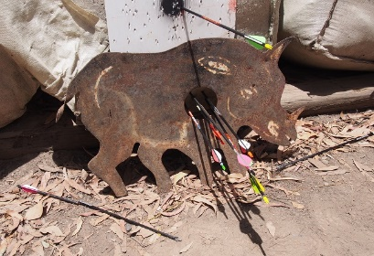
So for those that have not shot the ‘Steel Pig’???? Well essentially it is a 6mm steel target in the shape of a pig with a round hole, approximately 120mm diameter in the middle of it to put your arrow through – unscathed. Of course if you miss, then there is the resounding ‘Clang’ as the arrow hits the steel with the field tip, generally, disappearing up the shaft of the arrow. It doesn’t matter where you are on the range that ‘clang’ can be heard for miles. As Pete always says during this phase of the day, “Never mind, Ralph has plenty of arrows for sale” For all those shooting at the target there is always a hoot and a holler from everyone – less the archer that missed!
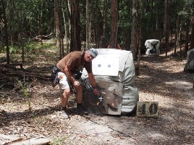
There is a lot of pressure if you’re up for the shot and if you hit the mark, so to speak, there is jubilation from the archer with a chance to win a prize and the knowledge you saved your arrow with generally a low levelled well done from the other archers. Any ‘clang’ is generally met with a lot of high pitched laughs and friendly banter from everyone else. The silence as the archer takes the shot is amazing, but post the release of the arrow is hilarious, dependant of the outcome of course!
If you missed the Moonterra Christmas party this year – never mind – there is always next year, and I have no doubt it will be just as challenging, will be filled with laughter and friendship shared with fellow archers – Merry Christmas to one and all and a very Happy New Year Moonterra, and look forward to seeing you all at some point in 2017.
Barrie Rhodes

FOR SALE
Items for sale:
PSE 40-50 lb – Stinger: $500
Contact – Bronwyn Pescud: bronwyn_archery@bigpond.com /for more information.
Comes with: hard & soft case, hip quiver, 8 x Tgt and 11 x hunting arrows including a release aid – A complete package, ready to go! (full details on FaceBook)
ADVERTISEMENT
Full Draw Archery Supplies – Call Ralph on 0413-054-722 for all your archery equipment advice and support.
Archery Tag – Call Andrew for a booking/ details on 02 4389 2606 or mobile: 0419 486 034 for bookings – A great alternative for kids/ buck parties and all ages.
NOTICE
EMAIL – If you have not received any emails from Bronwyn about club activities, we have had some email addresses bounce, so if your email account is working and you’re not getting emails from the Secretary – please send me your email address to:
hombrobaz@gmail.com and I will endeavour to get it sorted.

