Welcome to the November 2016 edition of Moonterra Archery Club Chat.
A busy month in October with 2 Club Point Scores completed, and a very successful working bee that had a great turn out of club members. In this month’s Chat, there is an article on John Boys and Donna’s trip to the world meet in Wagga, with Donna winning GOLD!

You may not be aware that the “Moonterra” Web Page has been up-dated, there is also a FaceBook (FB) Page for members only, and a shared Google Calendar for members not on FB. With plenty of mediums now available everyone can keep informed and up to date with club events. I would like to take this opportunity to thank Andrew Armstrong for his voluntary work in setting up and maintaining the original Web Page in his own time, and to personally thank him for the help in transfering and supporting me in taking over the web site – appreciated.

UPCOMING CLUB EVENTS
Sun 20 Nov 2016 – Club Point Score
Starts at 09:00 and everyone is encouraged to attend, don’t forget the score goes toward the annual club trophy. The point score is programmed to be conducted on the Green Route, a challenging route on any day and all are welcome
Unscheduled Activities
There have also been unscheduled activities at the range in Oct 16, with members offering up details on FB and the Google Calendar, for an opportunity to get together on unscheduled days at the range. The offers are there if you want to link in with other members at the range via social media.
CLUB PRESIDENT COMMENTS
I would like to take this opportunity to thank all those members who turned up and assisted on the working bee day in Oct. Thanks to Kerry for organising the bail press, and due to everyones effort we now have several new target bails available to replace the old ones on some of the ranges.
We have also had some vandals at the club – if you see any abuse of the ranges, club areas, please inform the committee ASAP.

OCT CLUB POINT SCORE
There was a good turn out for the club point score in Oct that started out as though it was going to be a wet one, like the September point score day, but the weather broke and it turned out a beautiful day at Moonterra with lots of sunshine.
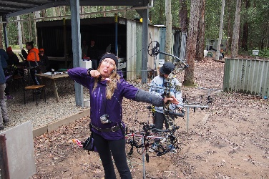
We were blessed with the presence of our Gold Medal Winner (Donna) and JB who gave us a run down on their trip to the World Meet in Wagga Wagga. A great opportunity for them, and their full story is this month’s article.
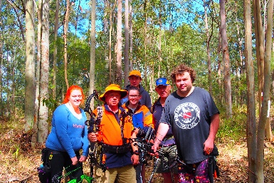
There were 3 large groups that participated in the round and some good scores also. It would be remisse of me not to mention Lez’s score of 590, yes 590 and proud of it too (-: Bill came around with one group and was always on hand to provide assistance and support the the newer members participating for the first time – thanks Bill for your support.
Our Gold Medal Winner!
The round was conducted on the Red Route with some great targets either side of the road, particularly since the changes have been made to it, with many longer shots 30 – 40 metres up and down hill.
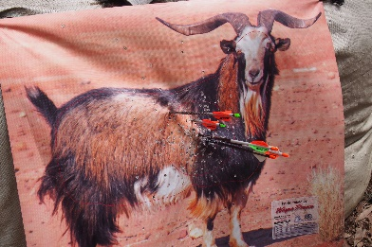
As always the round finished off whith some discussions about “The Shot of the Day”, who scored well, over a Lez Burger and a softie. I think the shot of the day was Amber – see the photos on the web page, and you’ll know what I mean. A great turn out, everyone had fun – a great way to spend a Sunday. A special thanks to Lez and everyone that set the range early and to JB for clarifying member alphabetical catagories!
____________________________________
MONTHLY STORY
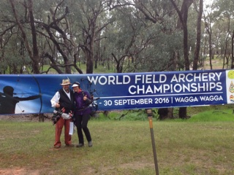
World Field Archery Competition/ Wagga Wagga – 2016
Australia hosted this year’s World Field Archery Championships in Wagga Wagga, NSW, which only comes around every 7 years. There is a requirement to qualify prior to the event at other meets which Donna and JB achieved. What you may not know is that Attila also was very close to qualifying, unfortunately had to pull out at a pre-comp meet due to Zara being ill and had to rush home midway through the competition. I said, not knowing: “mate no problem, there is always next year!” and that is when I found out it only comes to Australia every 7 years with next year’s comp to be held in Europe. Sorry Attila
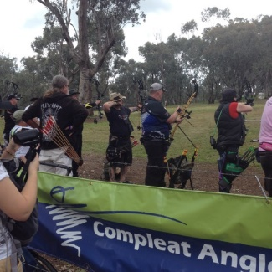
At this year’s event there were over 600 participants from all over the world, with Donna and JB representing themselves and our club at the competition. JB kept his identity secret, however he and his hat were a talking point at the competition. He was asked to do an interview for the local paper as he had become somewhat of a legend known as “John Boy Walton” and provided an interview under the assumed name. The Walton’s now have a whole new meaning to me and I am not sure JB fits the profile! – hmmm.
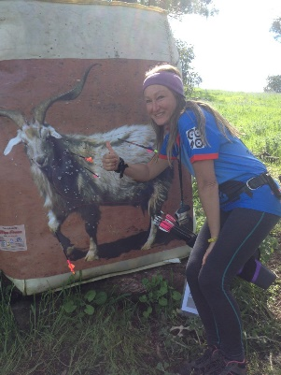
I spoke to JB and Donna after the meet at our recent Club Point Score, and they both had a wonderful time, their highlights being the opportunity to take part in an event such as the World Field Archery Championships and meeting people from all over the world. Both JB and Donna articulated that they enjoyed sharing stories with others at the competition and for Donna particularly, a great opportunity to experience and share competitor’s experiences and learning to be a better archer. When you think Donna started a little over a year ago with a recurve bow, and the targets were pretty safe, entering the competition with a compound bow and winning gold in her Division – fantastic effort. A huge congratulations from everyone at the club.
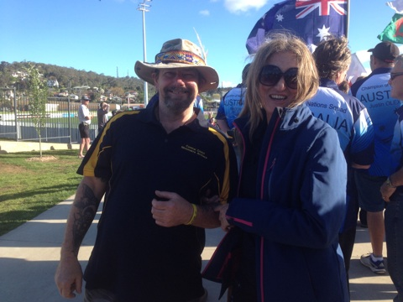
As highlighted before, the journey to get to the Championships is not just a matter of turning up and putting your name down. You have to qualify at events prior. One of the events they attended was the Nationals at Mudgee, which I believe JB rated best in NSW? You may not know, but JB’s PSE packed it in prior to the Championships (should have bought a Mathews mate ) and he replaced it with a new one just prior to the event, and with a few quick practice sessions prior, still managed to place 13th in his class (Male/ Hunter). Outstanding performance by both of them.
I think their memories will have to include their journey prior to the championships, sharing a camp fire with friends, shooting at different ranges and the travelling they have done together to get to their final goal – the World Field Archery Championships.
Congratulations to you both from everyone at Moonterra, and if you catch them at the club be sure to ask them about their experience, as I know they will be happy to share.
Barrie Rhodes

FOR SALE
Items for sale:
PSE 40-50 lb – Stinger: $500
Contact – Bronwyn Pescud: bronwyn_archery@bigpond.com /for more information.
Comes with: hard & soft case, hip quiver, 8 x Tgt and 11 x hunting arrows including a release aid – A complete package, ready to go! (full details on FaceBook)
ADVERTISEMENT
Full Draw Archery Supplies – Call Ralph on 0413-054-722 for all your archery equipment advice and support.

Archery Tag – Call Andrew for a booking/ details on 02 4389 2606 or mobile: 0419 486 034 for bookings – A great alternative for kids/ buck parties and all ages.

